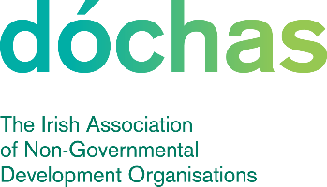 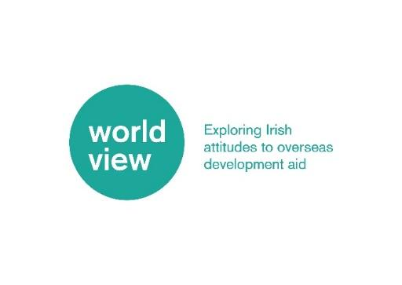

**Worldview Public Engagement Research Project**

**Quotations Sought: Strategic Consultancy**

1. **Background**

Dóchas is the Irish network for international development and humanitarian organisations. It is a vibrant network that aims to connect, strengthen and represent people and organisations working for a just, sustainable and equal world. We provide a forum for connection, co-operation and collaboration between our fifty-four members. Our mission is to enable international development and humanitarian organisations in Ireland to achieve greater impact by working together.

The Irish overseas development sector is committed to engaging Irish citizens in the fight against global poverty, inequality and injustice, but we are at a crossroads in terms of how we connect with the Irish public. We urgently need to seek new ways of connecting more people to the relevance of international development cooperation for the Ireland of today. The Sustainable Development Goals give us a broad, aspirational vision to what can be achieved, but further effort is needed to ensure it is made real and relevant to Irish citizens. There are many challenges including public trust in charities, focus on domestic issues and increasing narratives that are critical of the values and purpose of international development cooperation. There are many challenges including public trust in charities, focus on domestic issues and increasing narratives that are critical of the values and purpose of international development cooperation.

Against this backdrop, the [Worldview public engagement research project](https://www.dochas.ie/resources/worldview/) was developed by Dóchas in 2020, with Phase 1 running from 2020-2024. The project aims to reveal more about the views of Irish audiences and its varying constituents, not just on what they believe when it comes to international development cooperation, but why they believe it. From this research, a shared collective narrative about international development is emerging, which allows us to connect with more people in Ireland about its relevance and importance. In early 2025, the project successfully was extended to Phase 2, funded by Dóchas, Dóchas members, and Irish Aid. The project wants to continue building momentum and aligning the research with current trends, as well as continuing the longitudinal research from Phase 1.

1. **Tender**

Dóchas wishes to contract strategic consultant(s) with specific experience and expertise in researching public perceptions of international development and ODA. The consultant(s) will work with the project manager and in collaboration with the Worldview governance to identify, develop, and analyse topics for the dynamic ‘Part B’ of the research, and act as a ‘critical friend’ to the project over the next 5 years.

1. **Scope of the consultancy and Specific Outputs**

The consultant(s) will work with the project manager and in collaboration with the Worldview governance to identify, develop, and analyse topics for the agile ‘Part B’ of the research. In addition to the static, longitudinal research, the ‘Part B’ section allows the research to chose a relevant topic of interest for a certain year to explore. This aspect of the project enables the research to remain dynamic to trends each year, while maintaining its longitudinal validity. Previous topics have been [drivers for ODA support](https://www.dochas.ie/resources/worldview/quantitative-findings/quantitative-findings-2/), [ODA message testing](https://www.dochas.ie/resources/worldview/quantitative-findings/survey-3/), [the SDGs, climate change](https://www.dochas.ie/resources/worldview/quantitative-findings/survey-4/), [the war in Ukraine, the cost of living crises](https://www.dochas.ie/resources/worldview/quantitative-findings/survey-2/), and the latest Wave 5 [quantitative imagery research,](https://www.dochas.ie/resources/worldview/qualitative-research-outputs-2/) which explored the Irish public’s responses to images used by Dóchas members in their campaigns

The first step in Worldview Phase 2 is a revision phase from January to June. The annual research will then occur in the latter half of the year, with a Wave 6 launch event expected in the final quarter. The consultant(s) will guide and support discussions on the Part B topic for this year in collaboration with our member’s needs, formulating the survey questions accordingly, analysing the Part B responses, presenting the insights and results at the launch event, and act as a ‘critical friend’, providing feedback throughout the various phases of the project in order to avoid any pitfalls and maximise success and efficacy of the project.

***Specific outputs:***

* **Research Topic Guidance:** Along with our members, assist us in using the existing research findings and current cultural and political trends to decide the Part B topic for this year.
* **Research Question Design & Analysis:** Develop the ‘Part B’ survey questions; how they are formulated, and analyse the results to create a deck/report on the results and insights that can be ascertained. Analysis will be aligned to the [Worldview segmentation](https://www.dochas.ie/resources/worldview/meet-the-worldview-segments-and-personas/) groups to understand whether segments are better drivers or individual factors and whether drivers vary for each segment.
* **Results Presentation to Dóchas Members:** Present the research findings to Dóchas members at the end of the research cycle at an in-person launch event.
* **Ongoing Feedback:** Act as our “critical friend”, coming in at two/three key phases of the project ensuring we are on the right track and not heading towards any pitfalls.

**Terms of Contract and Timing**

Dóchas is seeking quotes from strategic consultants for this strategic consultancy work. To apply, please send your quotation for the work outlined here and a proposed breakdown of the work into days sent via email to Niall(at)dochas.ie. All taxes including VAT, PAYE, PRSI or USC in respect of this consultancy need to be included in the quotation. The deadline for quotations is 6pm (Irish time), Sunday 30 March 2025. You can request the supplementary segmentation process outline document from Niall(at)dochas.ie for your own understanding.

An indicative timeline of the days in Phase 1 was:

|  |  |  |  |
| --- | --- | --- | --- |
|  | **Activity** | **Detail** | **Days** |
| 1 | Instrument design | Survey drafting questions for Part B research | 1 day |
| 2 | Modelling analysis – aid support | Coding and analysis | 2 days |
| 3 | Sensitivity checks; visualisation |  | 1.5 days |
| 4 | Report and deck write up | Slide deck with the complete analysis, interpretations and insights for Dóchas | 1.5 days |
| 5 | Stakeholder presentation | Presentation, Q & A and insight session with Dóchas stakeholders | 0.5 days |
|  |  | **Total days** | **6.5 days** |

Payment for the days worked will be made on the production of an invoice when work is completed to the satisfaction of Dóchas. The consultant(s) can work remotely with in-person attendance expected for the launch events each year. The consultant(s) will be expected to communicate regularly on progress with Dóchas and inform Dóchas of any potential delays or schedule changes. Confidentiality relating to Dóchas data and processes not in the public domain will be respected by the consultant.