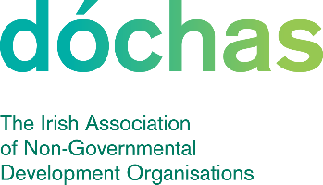 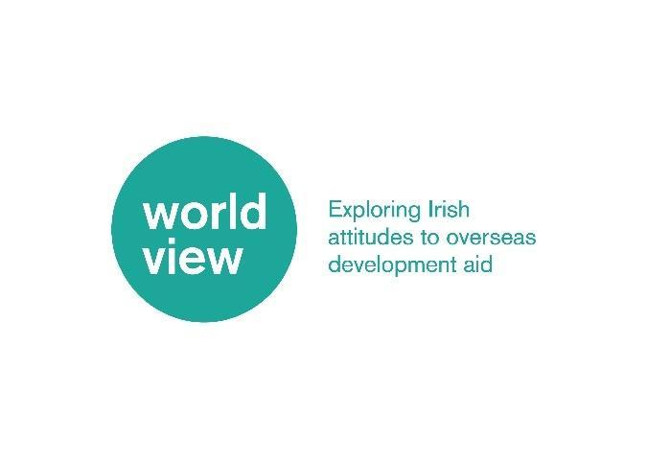

**Terms of Reference**

**Worldview - Dóchas Public Engagement Research Project**

**Invite to Tender: Annual Tracker Research**

# **Background**

[Dóchas](https://www.dochas.ie/) is the Irish network for international development and humanitarian organisations. It is a vibrant network that aims to connect, strengthen and represent people and organisations working for a just, sustainable and equal world. We provide a forum for connection, co-operation and collaboration between our fifty-four members. Our mission is to enable international development and humanitarian organisations in Ireland to achieve greater impact by working together.

The Worldview Public Engagement Research Project (Worldview), developed by Dóchas and supported by Dóchas members and Irish Aid, is a longitudinal study aimed at understanding Irish attitudes towards international development cooperation and official development assistance (ODA). Worldview Phase 1 took place between 2020- 2024. This included robust annual research, audience segmentation, engaging diverse stakeholders and implemented strategies to better understand and shape Irish public perceptions of ODA. The project seeks to uncover not only what people in Ireland believe but also what informs and influences these beliefs and attitudes, ultimately shaping their actions and responses to global issues and ODA, all while aiming to preserve the civil society space.

Worldview has successfully been extended for another five years, entering a new phase – henceforth known as Phase 2. To initiate this Phase, a redesign stage will occur from January to June 2025 to revise the annual survey with input from our members to ensure it remains relevant, while also ensuring to maintain the longitudinal fidelity of the project results, including the crucial segmentation process, which yield the Worldview segments. See below the outcome of the survey from 2024.

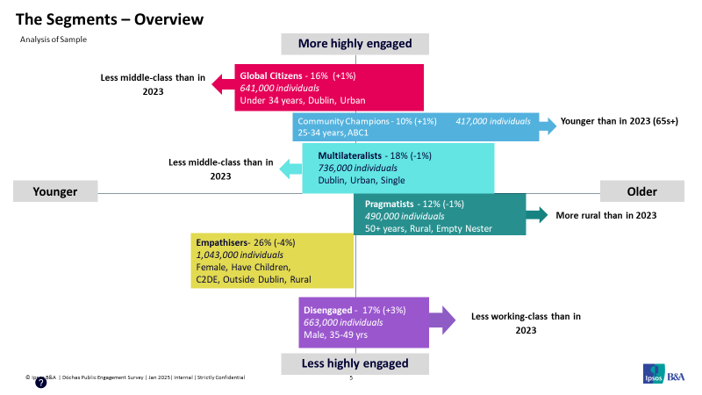

# **Research**

2.1 Phase 1 Research Components

The Irish overseas development sector is committed to engaging the Irish public in the fight against global poverty, inequality and injustice, but is at a crossroads in terms of how we connect with the Irish public. Worldview enables new ways of connecting more people to the relevance of international development cooperation for the Ireland of today. Worldview’s nationally representative survey results are a key tool for the INGO sector to demonstrate continued support for the provision of overseas development, and the Worldview segments enable the creation of innovative and targeted ways of reaching those most to least engaged in the sector. The project also informs Dóchas’ external voice and messaging and our efforts to promote best practice among our members in the use of images and messages.

To date, the Public Engagement Research Project has broken down into several parts as follows:

1. Desktop research into what data and research already exists in relation to this topic in Ireland and abroad, and how can it feed into and inform what we are aiming to achieve through this piece of work.
2. Audience segmentation data and analysis which has been used to profile the Irish public. This research is used to identify and to segment the audience into clearly defined and usable groups that Dóchas members can utilise in their communications and engagement strategies.
3. Annual survey to understand Irish attitudes, behavioural engagement with development cooperation, drivers of support, and the levers to change attitude and behaviour.
4. Focus groups (based on the segmentation survey) to discern 1) the current beliefs and motivations of the Irish public in relation to overseas development aid; 2) the communication content, style and channels that are likely to enhance support for overseas development aid; 3) how these vary from one audience group to another; and 4) the emotional responses of the Irish public to Dóchas member’s images.
5. Dynamic cultural research carried out by Development Engagement Labs (DEL), who identify relevant topical themes for the agile ‘Part B’ quantitative questions each year. Typically, 7-10 questions are included in the quantitative survey which are formulated and analysed by DEL.

2.2 Longitudinal Fidelity from Phase 1 to Phase 2

Central to Worldview is the annual survey which has been rolled out five times since 2020. This is an annual 25-minute survey with a nationally representative sample of 2-2,500 respondents, conducted online. There are approximately 72 main questions which include standard closed and open-ended items, some key demographic questions, and questions on current political and cultural trends that are provided by our strategic advisors. The Worldview audience segments have been developed over the years. The Worldview research has identified six clearly defined and targetable audiences to reflect the Irish public ranging from young (18+) to old and less to highly engaged across a range of socio-economic demographics and measures including issues of importance, life-guiding principles and values and worldviews. For further details of the components of this research, you can request the ‘Market Research Tender Package’. The package contains the following:

* The **annual research script,**with the questions used in the segmentation indicated.
* The **segmentation explainer**
* The **discriminate analysis explainer**
* The **technical field report** (sampling, weighting, stratification)
* The **Wave 5 Quantitative Findings tables**

It is critical that Phase 2 maintains research fidelity surrounding key questions, and those that inform the Worldview segments.

An element of the researcher’s work in this Phase 2 Year 1 will be to review and consider the survey questions in full and suggest ways of reducing the volume of questions. This will occur during the redesign phase running until June. Researchers will be expected to indicate which questions a) cannot be removed, b) could potentially be removed but may cause some discrepancies between Phase 1 and 2 and/or impact the segmentation, and c) which can be removed with little to no impact on research fidelity.

After this phase, the survey will be amended and remain the same for the rest of Phase 2. An initiation meeting for the annual research will take place in late May with survey drafting expected to start in June. See Appendix 1 for the proposed project timeline.

# **Purpose**

The scope of this tender is to continue the well-established audience market research of Worldview and its segmentation on Irish audiences, identifying and segmenting the audience into the clearly defined and usable groups.

# **Timeline**

In the first year of this contract, the work is divided into two stages. Stage one is to support the project’s redesign phase (April – May). This includes:

* Researcher review of survey questions and recommendations for decreasing the survey size
* Working with the project manager to facilitate member’s input on survey questions

After this stage, the annual research phase will begin immediately. The second stage will run in Year 1 from June until October and will comprise of:

* Wave 6 initiation meeting
* Survey drafting
* Survey signed off by Worldview project manager
* Survey scripted and tested
* Survey in field
* Coding and editing of survey data
* Analysis of data, including segmentation analysis
* Topline survey findings
* Preparation of PowerPoint report with commentary
* Full report of findings
* Presentation of findings at Wave 6 launch event

After Year 1, activities will only include those outlined in the second stage and will repeat for 5 years. See Appendix 1 for projected timeline.

# **Deliverables**

**A. Survey volume review:** Full review of questions and recommendations on ways to reduce the volume of survey questions in collaboration with the project manager and members, while maintaining research fidelity.

**B. Datafiles:** Upon completion of fieldwork, the survey company will provide to Dóchas the complete raw, weighted dataset (SPSS, .csv format); an aggregated Excel file of the marginals with cuts pre-specified by Dóchas (e.g. age, gender, region, party-ID); a final instrument script; and a brief technical report including information on weighting variables (selection and post-stratification), length of fieldwork, sampling, etc.

**C. Audience Segmentation:** They market research company will design and implement the audience segmentation from Phase 1 in line with the ‘Golden questions’ indicated in Appendix 2. The survey company will use the short report on the items used in the segmentation, and step-by-step explanation of the methods used in the ‘Market Research Tender Package’ to create the segmentation for replication.

**D. Analysis and Final Report:** The market researchers will provide a robust analysis of all key variables; drivers analysis with appropriate modelling; analysis appropriate for experimental designs. The reporting will also include a PowerPoint presentation to be presented to the Worldview Steering Group and later the wider membership. Examples to date can be found [here](https://www.dochas.ie/resources/worldview/quantitative-findings/survey-5/).

# **Tender**

Dóchas seek tenders from qualified/registered partners based on the technical specifications, alignment with Phase 1 capabilities, minimum sampling size to maintain the project’s nationally representative element and on costings.

# **Budget & Contract**

Worldview wishes to engage researchers on a 3-year contract. The maximum available budget for this project is 45,000 Euro per annum inclusive of VAT or other taxes. This will include the short revision phase (year one only), the annual research with a nationally representative sample for an online survey, with the specific number of questions to be decided. Any expenses to be agreed in advance.

# **Application Process**

To request the full ‘Market Research Tender Package’, please email Niall(at)dochas.ie. Applications can be sent to the same email address no later than 6pm (Irish time), Sunday 30 March 2025.

The proposal should include:

1. **Explanation of alignment to established methodology and approach, including:**
   1. The tenderer’s understanding of what is required and how they will provide it
   2. A brief outline of the sampling strategy to meet the established segmentation profiles, including what is the minimum sample size needed to be nationally representative
2. **Proposed overall cost and cost breakdown for the project to include:**

Costings for samples of minimum national representation size, 2,000 and 2,500 respondents

Costings for future waves after 3 year contract

1. **A proposed timeline to align with the timeline in Appendix 1**
2. **Case studies of successful delivery of similar projects**

If any of the above elements are omitted the submission, the tender will be automatically excluded from the selection process.

The criteria for selection are outlined below, weighted as per the percentages:

1. Overall ability to align with the Phase 1 research, ensuring its longitudinal fidelity, including methodology, segmentation, technical specifications, and national representation (50%)
2. Cost (30%)
3. Previous experience of conducting similar research, as evidenced by quality of the

case studies and overall tender (20%)

# **Appendix**

**Appendix 1. Projected Project Timeline**

| **Timeline** | **Activity** |
| --- | --- |
| 10 March – 10 April | Out to tender for surveying/ audience analysis company w/c for 3 weeks  Review, selection and finalise tender 31 March – 9 April |
| 14 April – 16 April | Initiation meeting and timeline agreed with researchers |
| 16 April – 28 April | Researcher survey review begins and identification of areas for decrease in survey questions. Researchers should identify what a) cannot be removed, b) could be removed but may cause some discrepancies between Phase 1 and Two and/or impact the segmentation, c) which can be removed with little to no impact on research fidelity. |
| 28 April – 2 May | Researchers feedback review of Phase 1 – Project manager will then hold focus group with members for their input |
| 13 May – 15 May | Meeting to review recommendations from Member focus group – a follow up member focus group will happen afterwards to keep them informed or relay any other updates |
| 26 May | Decision on all changes to Phase 2 surveying |
| 27 May | Wave 6 initiation meeting |
| 2 June – 13 June | Survey drafting (2 weeks) |
| 16 June | Survey signed off by Worldview project manager |
| 16 June – 27 June | Survey scripted and tested (10 days) |
| 27 June – 8 August | Survey in field (6-7 weeks) |
| 11 August – 22 August | Coding and editing of survey data (10 days) |
| 22 August -29 August | Analysis of data, including segmentation analysis |
| 29 August – 1 September | Topline survey findings |
| 29 August – 12 September | Preparation of PowerPoint report with commentary |
| 15 September – 18 September | Full report of findings |
| October | Presentation of findings at Wave 6 launch event |